Azure Blob Storage
Azure Blob Storage is Microsoft’s cloud-based service designed to store large amounts of data of various types — including structured, semi-structured, and unstructured data.
It is ideal for storing files such as CSV, text, Excel, JSON, Parquet, Avro, XML, images, videos, backups, and logs.
The term “Blob” stands for Binary Large Object, meaning it can store any type of binary data. Blob Storage provides a flat namespace, meaning all files (blobs) are stored in containers within a storage account, rather than in a traditional hierarchical folder system.
Azure Blob Storage is highly scalable, secure, and cost-efficient, making it suitable for:
- Storing and serving large files (media, documents, etc.)
- Data lakes and analytics workloads
- Backup and disaster recovery
- Archiving and compliance storage

Create an Azure Blob Storage
→ Go to Azure Portal
→ In the search bar, type “Storage Accounts” or “blob”
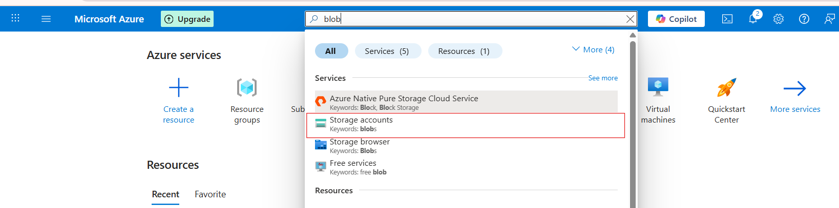

→ Click on storage accounts and click on create button
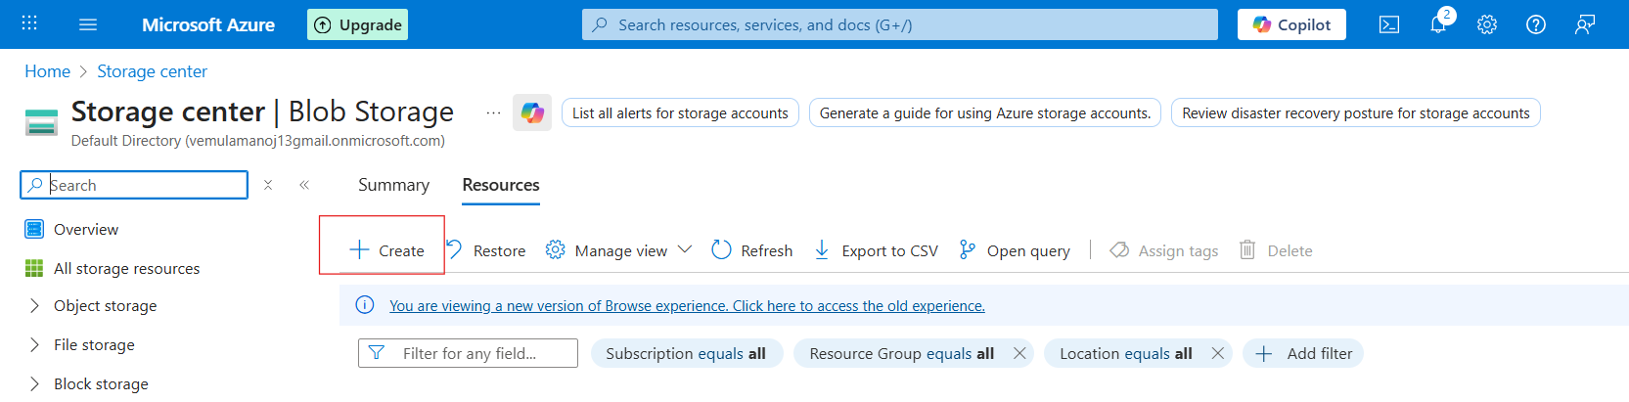

After clicking the Create option, we will see the Basic details section. Fill in all the required details and then click the Review + Create button.

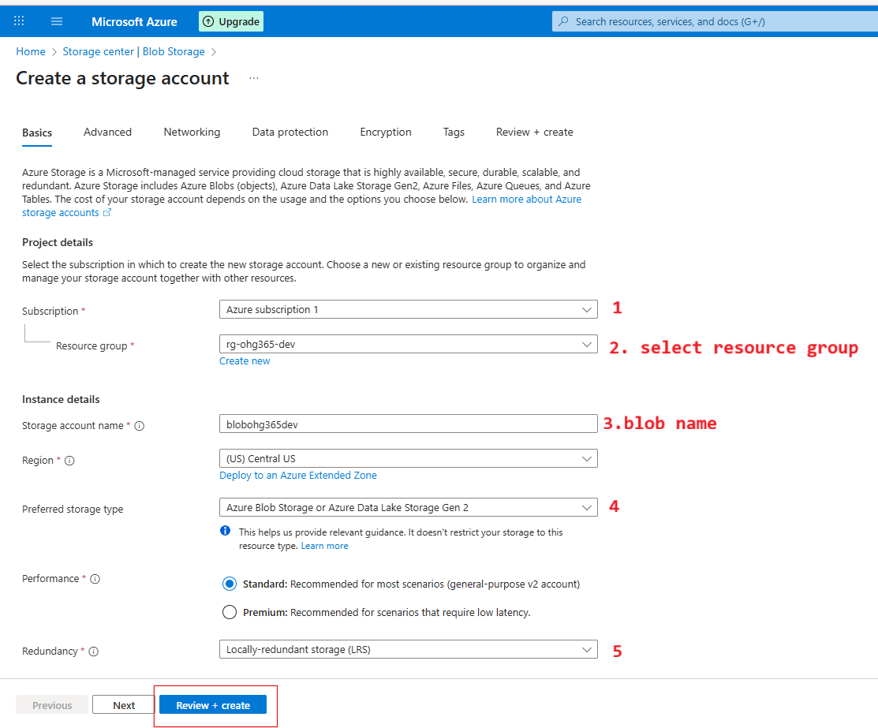

1️⃣ Subscription
- This is where you choose which Azure Subscription will own this storage account.
- A subscription is linked to your billing and access control.
- Example: You might have separate subscriptions for development, testing, or production environments.
You selected: Azure subscription 1

2️⃣ Resource Group
- Choose or create a Resource Group to organize related Azure resources.
- Resource Groups act like folders — all your related resources (VMs, storage, databases) are stored here for easy management.
- In your case, you selected rg-ohg365-dev, which is perfect for development resources.
Tip: Keeping related resources in the same group helps you track cost, permissions, and manage everything easily.
3️⃣ Storage Account Name
- This is the unique name for your storage account (like a domain name).
- It must be globally unique, lowercase, and 3–24 characters long.
- This name will form part of the URL to access your data.
Example:
If your name is blobohg365dev

4️⃣ Preferred Storage Type
- Select what kind of storage service you want to enable.
- The default (and most common) option is:
Azure Blob Storage or Azure Data Lake Storage Gen2
This means your account will support:
- Blob storage (for files, media, etc.)
- Data Lake capabilities (for analytics and big data processing)
Tip: Keep this as default unless you have a specific need for file shares or queue services.

5️⃣ Performance & Redundancy Settings
Performance:
- Standard: Uses HDD-based storage — cheaper, good for general use.
- Premium: Uses SSD-based storage — faster, ideal for workloads needing low latency (like databases or VMs).
You selected: Standard (recommended)

Redundancy
Defines how Azure replicates your data to keep it safe.
Option | Meaning | Copies of Data
LRS (Locally-redundant storage) | Stores 3 copies of your data within a single data center | 3
ZRS (Zone-redundant storage) | Stores copies across 3 availability zones within the same region | 3
GRS (Geo-redundant storage) | Replicates your data to a secondary region for disaster recovery | 6
RA-GRS (Read-access Geo-redundant storage) | Same as GRS, but also provides read access to the secondary region | 6
You selected: LRS (best for development and testing).

After clicking Review + Create, the Blob Storage section will appear. Review all the details you have provided, and then click the Create button.
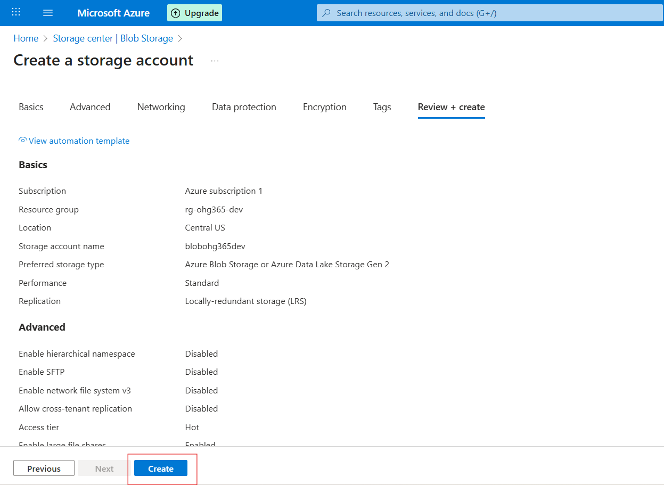

After clicking the Create button, we will be taken to the Overview page. Then click Go to resource.
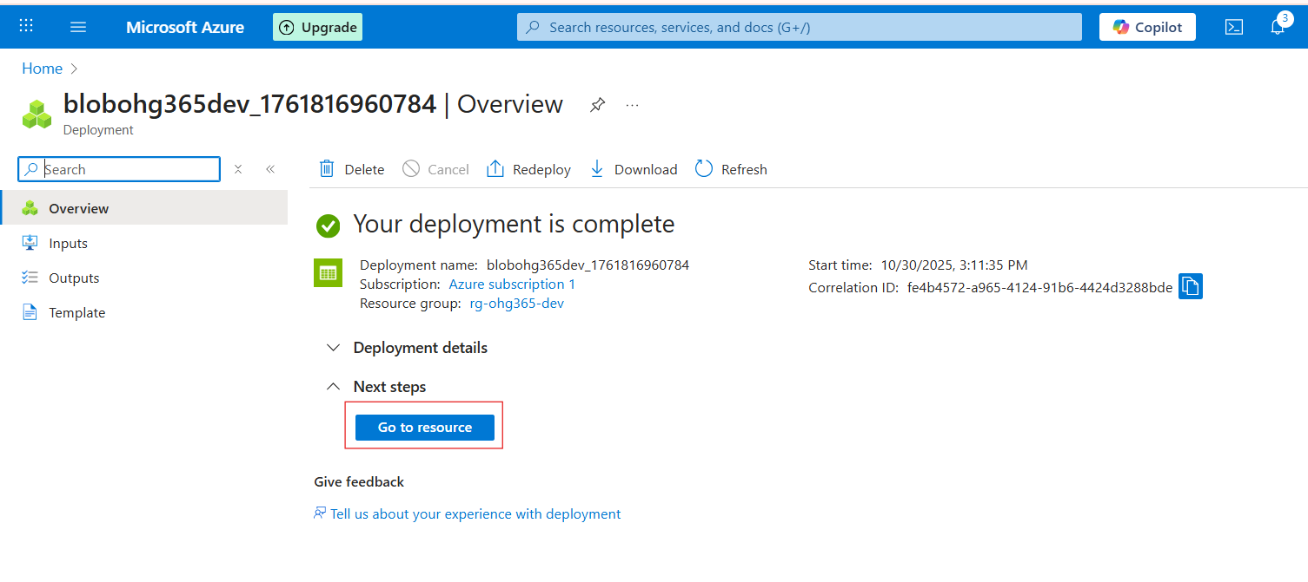
Navigate to Your Resource Group
- In the left-hand menu, click on Resource groups
- Find and click your resource group — in your case:
→ rg-ohg365-dev
- Check for the Storage Account
- Inside the Overview tab of your resource group, you’ll see a list of all resources.
- Look for an item that looks like this:
Type: Storage account
Name: blobohg365dev (or whatever name you used)
If it appears there, 🎉 congratulations — your Blob Storage account has been successfully created
